**NATIONAL UNIVERSITY OF SCIENCES AND TECHNOLOGY**



**Fundamentals of Programming**

**Home TASK (MANUAL 8)**

**Course Instructor:** Dr Khawaja Fahad Iqbal

**Lab Instructor:** Muhammad Affan

**Student Name:** MANAHIL SHAHZAD

**CMS ID:** 466695

**DATE:**

**05-12-2023**

**Task 1:**

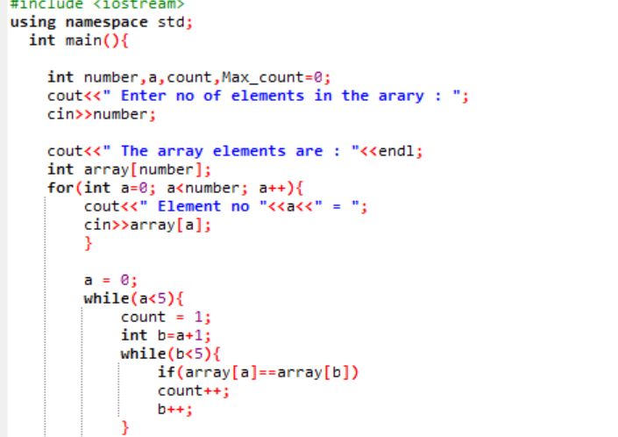

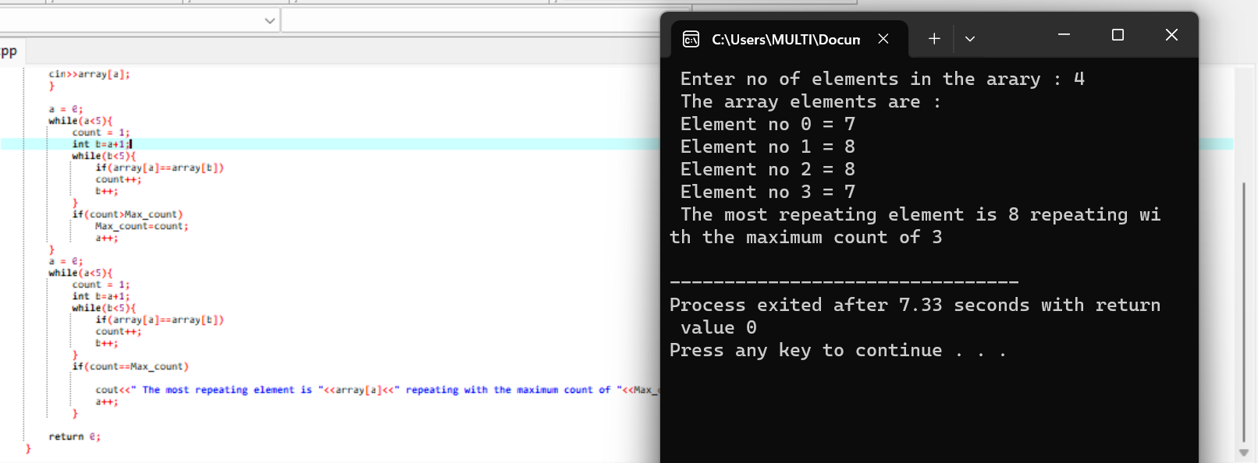

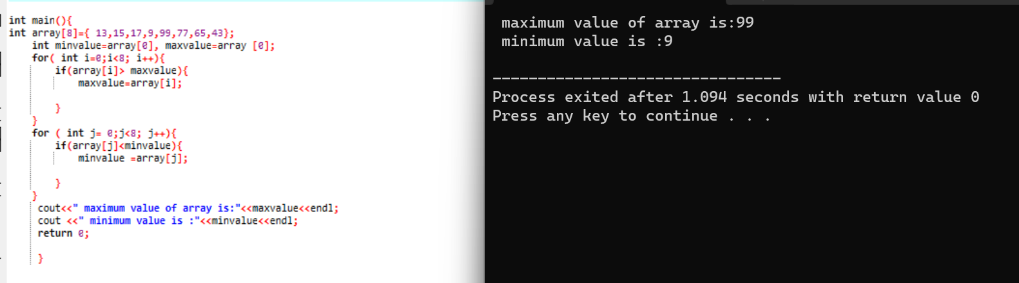**TASK 2:**

**TASK 3:**

